**Tutorial -SQL Exercises 2**

1. **List the maximum and minimum salary for each job type**

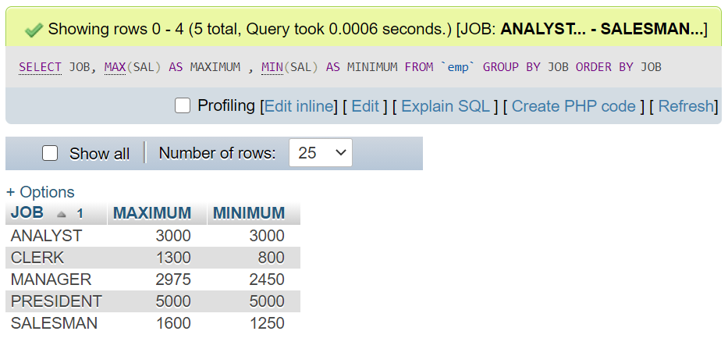

1. **For each salesman, list his name, salary, commission, and percentage commission of salary.**

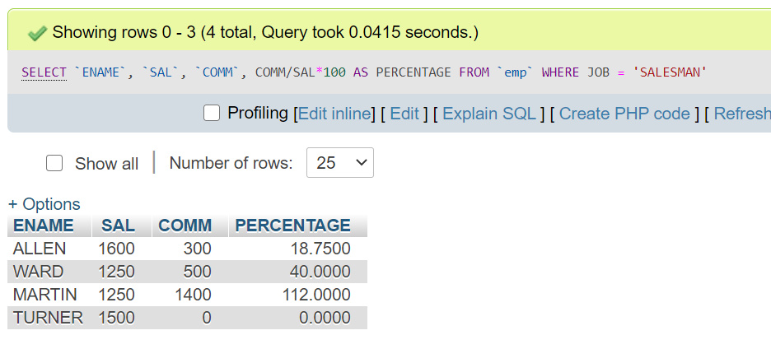

**To round off for 2 decimal places, ROUND( (COM/SAL*100) , 2 ) is used**

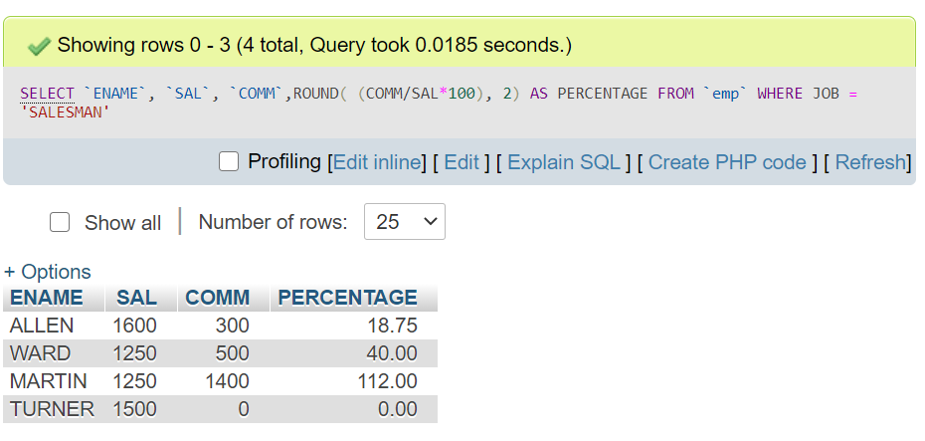

1. **Find all salesmen whose commission is greater than 5% of their salary**

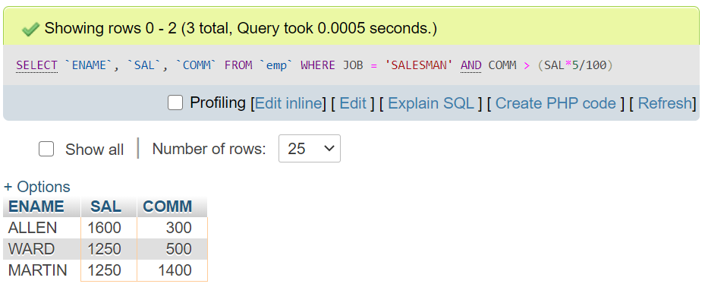

1. **Find out how many managers there are without listing them**

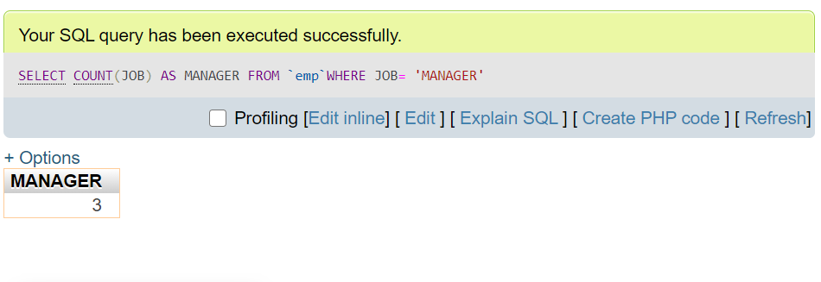

1. **Find the minimum salary of all the employees**

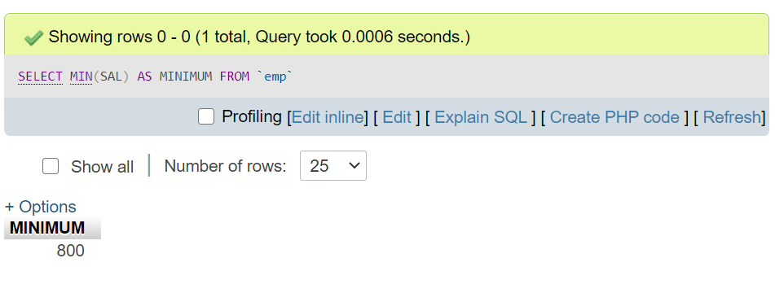

1. **Find the employees who earn the highest salary in each job type**

**SELECT JOB, ENAME, SAL**

**FROM emp**

**WHERE SAL IN**

**(SELECT MAX(SAL)**

**FROM emp**

**GROUP BY JOB)**

**ORDER BY JOB**

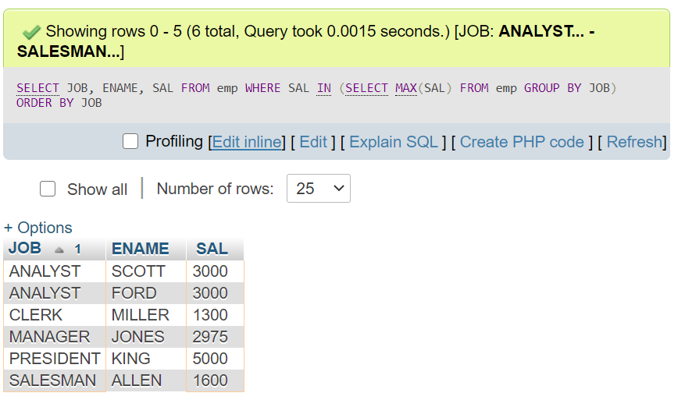

1. **Find the names of those employees with the minimum salary for their job. Print the jobs in ascending order of their minimum salary.**

**SELECT `ENAME`, `SAL` , `JOB` FROM `emp`**

**WHERE SAL**

**IN (SELECT MIN(SAL)**

**FROM emp**

**GROUP BY JOB)**

**ORDER BY SAL**

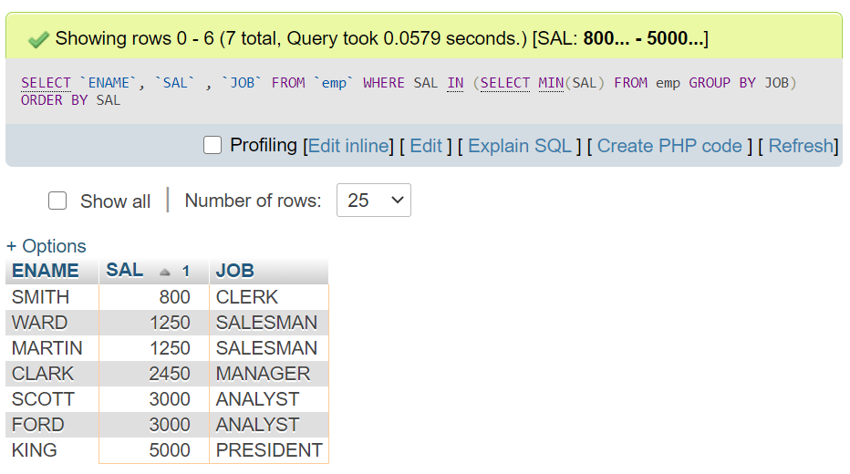

1. **List all departments where there are no employees**

**SELECT DEPTNO , DNAME**

**FROM dept**

**WHERE DEPTNO NOT IN (SELECT DEPTNO FROM emp)**

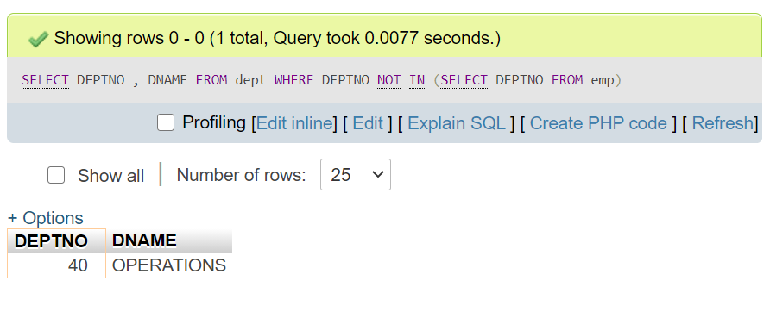

**2nd METHOD**

**SELECT dept.DEPTNO, dept.DNAME**

**FROM dept**

**LEFT OUTER JOIN emp**

**ON dept.DEPTNO = emp.DEPTNO**

**WHERE emp.DEPTNO IS NULL**

